"The Falcons"

ABOUT THE PRODUCTION

Tagline

Winning isn’t everything

Short synopsis

In The Falcons, we follow JÓN (10) and his teammates as they travel to Westman Islands, a large island off the south coast of island, to take part in a large football tournament that is held there every summer. Through exciting matches Jón discovers a whole new side of himself as a football player and finds that he can take on more responsibility than he ever imagined. Especially when he accidentally breaks his team captain’s arm during one match.

Long synopsis

In The Falcons, we follow JÓN (10) and his teammates as they travel to Westman Islands, a large island off the south coast of island, to take part in a large football tournament that is held there every summer. Through exciting matches Jón discovers a whole new side of himself as a football player and finds that he can take on more responsibility than he ever imagined. Especially when he accidentally breaks his team captain’s arm during one match.

The boys’ lives take an unexpected turn however, when they witness ÍVAR (10), a player in one of the opposing team, getting roughed up by his father TÓTI. The otherwise lighthearted and adventurous football tournament turns into a dramatic rescue mission where the boys try to save Ívar from his father. But it's easier said than done when nobody believes the boys and when even the Chief of Police and Tóti’s brother doesn’t want to listen, the boys need to muster up every ounce of confidence to find a way to prove what really happened and save Ívar from his broken home.

Jón and Ívar, sworn enemies on the field, go together on an emotional journey with both dramatic and exciting consequences and find a friendship that will endure – and a nearby volcano will wake from its slumber.

The Falcons is based on the first book in a series of popular children’s books about Jón and his friends, written by the acclaimed children’s author and entertainer Gunnar Helgason. With their vibrant mix of exciting football stories and genuine and affectionate stories of growing up, these books have been a massive hit with children and have sold in record breaking numbers.

Technical Data

Title: The Falcons
Original Title: Víti í Vestmannaeyjum
Genre: Family
Production Year: 2017/2018
Month of start & end of shooting: 21. June 2017 – 4. August 2017
Country of Origin: Iceland
Language Spoken: Icelandic
Duration: 97min or 92min
Shot on: Arri Alexa
Screen Ratio: 2048x858 DCI Scope 2.39
Format (ex. DCP, 35mm): DCP
Sound format: 5.1 Surround and Stereo
Domestic release: 23. March 2018
Incl. Distributor name: Samfilm
Admission/rating:
Incl. PG, 18+ etc
Target Group: 6-14 years old
Production Company: Sagafilm
Producer: Anna Vigdís Gísladóttir and Thorhallur Gunnarsson
Co-producer and Company/Country
Executive Producer(s) Thorhallur Gunnarsson, Hilmar Sigurdsson, Kjartan Thor Thordarson and Ragnar Agnarsson.
Cinematographer: August Jakobsson IKS
Editor: Guðni Hilmar Halldórsson and Bragi Thor Hinriksson
Sound Designer: Birgir Tryggvason
Composer: Kristján Sturla Bjarnason
Still photographer (If several please list separately)
Scriptwriter: Gunnar Helgason, Jóhann Aevar Grímsson, Ottó Geir Borg
Director: Bragi Thor Hinriksson
Cast:
Lúkas Emil Johansen
Róbert Luu
Páll Steinar Guðnason
Þórður Hólm
Theodór Ingi Óskarsson
Þórður Kalman Friðriksson
Egill Helgi Guðjónsson
Stefán Bogi Guðjónsson
Daði Berg Jónsson
Ísey Heiðarsdóttir
Viktor Benóný Benediktsson
Jóhann G. Jóhannsson
Björn Óli Snorrason
Oliver Einar Nordquist
Jón Arnór Pétursson
Arnar Harðarson
Patrik Nökkvi Pétursson
Baldur Björn Arnarsson
Sigurður Kári Harðarson
Óli Gunnar Gunnarsson
Ilmur Kristjánsdóttir
Gunnar Hansson
Katrín Ynja Hrafnkelsdóttir
Nanna Kristín Magnúsdóttir
Sigurður Sigurjónsson

Budget (EUR/USD)
Financiers / Investors or other involved production partners

ABOUT THE DIRECTOR
Director's statement – by Bragi Thor Hinriksson

“The Falcons is my most challenging film so far and combines heart, strength and character. It’s a story of dreams, expectations and strong friendship. It’s been a great privilege directing young impressive talents playing football in this spectacular landscape.”

Bragi Thor Hinriksson - Director's bio
Bragi Thor Hinriksson is an accomplished award-winning Icelandic film director. He has directed six feature length films, four of which have enjoyed enormous box office success locally in Iceland with domestic box office numbers rivalling the likes of Harry Potter, Toy Story 3 and Avatar.

KEY CAST

Lúkas Emil Johansen

Lúkas Emil Johansen plays Jón the main character of The Falcons.

Viktor Benóný Benediktsson

The Falcons is Viktor’s first acting role.

Johann G. Johannsson

Joi Johannsson is an awarded Scandinavian actor born and raised in Iceland. He graduated Magna Cum Laude from University of Hartford, Connecticut in 1994 with a B.A degree in Theatre and Cinematic Arts.
Joi made his acting debut in 1986 in an international TV mini-series called Nonni and Manni. Since then, he has appeared in over 40 international films and TV productions. The most recent being Fortitude 2 (UK) where he joins an international cast lead by Dennis Quaid. Other major roles/productions include Clint Eastwoods Flag of Our Fathers (USA) and a lead in Baltasar Kormakurs (Everest, Two Guns) The Deep (Iceland) (Ten Edda Awards and garnered recognition by the Nordic Council, European Film Awards, the Göteborg Film Festival, Les Arcs European Film Festival, and the Mar del Plata Film Festival.) Joi also can be seen in a leading role in the TV mini-series The Lava Field (Iceland), a big role in the Danish film The Shamer's Daughter and lead opposite Franka Potente in the German films: Solveig Karlsdottir - The Death in Westfjords and Death of the Elf Woman.

CREW
Anna Vigdis Gisladottir and Thorhallur Gunnarsson – Producer
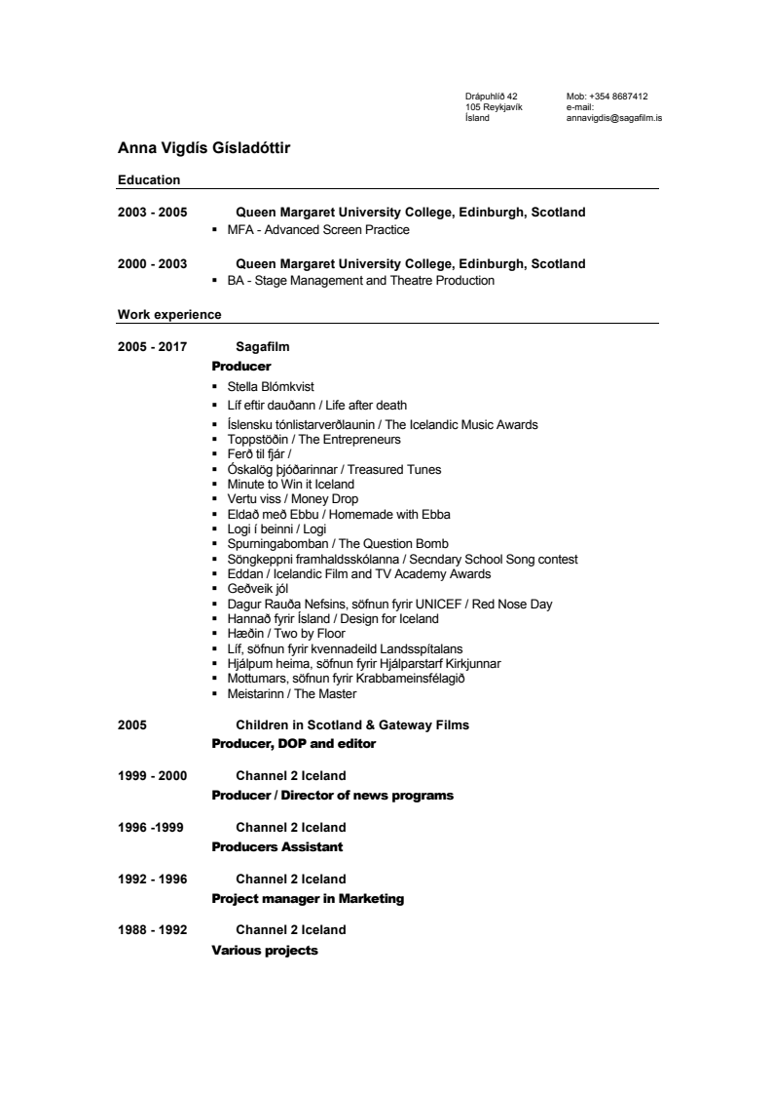
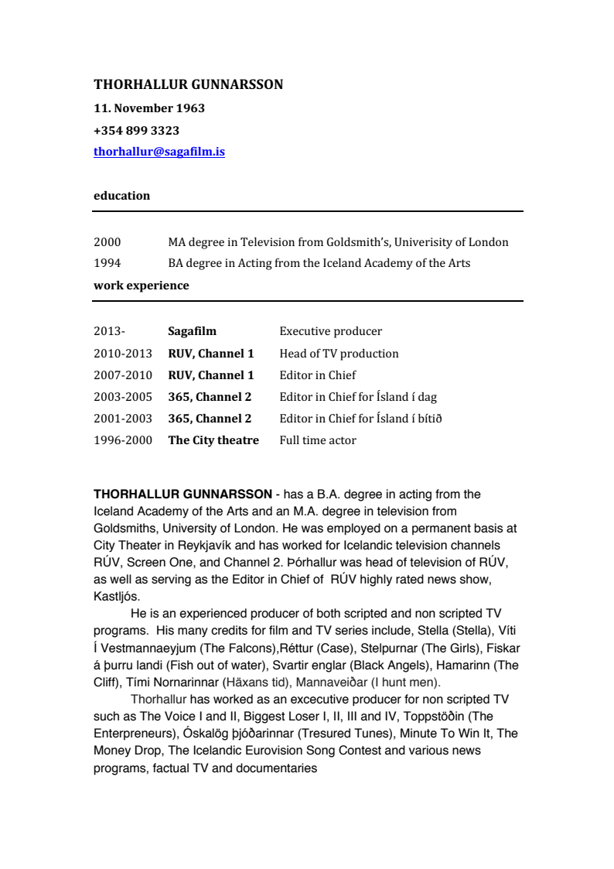

August Jakobsson IKS – Director of Photography
https://www.augustjakobsson.com/

Gudni Hilmar Halldórsson and Bragi Thor Hinriksson – Film Editor
Gudni Hilmar Halldórsson is an editor known for The Press (2007) Stella Blómkvist (2017) Case (2015).
Bragi Thor Hinriksson is the director and editor of The Falcons, he is known for editing Promises (2017) Harry & Heimir: Morð sem allra fyrst (2014) Algjör Sveppi Trilogy (2009, 2010, 2011)

Kristján Sturla Bjarnason – Composer
Composer Kristjan Sturla was born in Mosfellsbaer, Iceland which is a small town in the area next to Reykjavik. He started studying the piano and music theory from young age so music has always been a big part of his life. Before writing music for pictures Kristjan was in many bands and worked with many musicians as a piano player, a recording engineer and as a producer. Kristjan has always been a fan of the movies and started composing music for short films in high school very early on. When he was studying Psychology in the University he caught his first break to compose music for a feature length film. That project was one of the most famous movie franchises in Iceland, “Algjör Sveppi”. The movie was the third one in the quadrology of the adventures of “Algjör Sveppi” and was called The Magic Wardrobe. He also wrote the music to the fourth one, The Biggest Rescue. Since then Kristjan has composed music to nine feature length films, several shorts and documentaries as well as two television series. His work has touched on variety of genres such as thrillers, horror, adventure, comedy and many more. Kristjan also does music for tv commercials and teaches music and movie making in an elementery school in Reykjavik when he is not doing music. Despite for young age, Kristjan has credits that feature some of the most popular movies in Iceland as well as smaller indie films and other projects.

Official website: www.kristjansturla.com

COMPANY PROFILES

Production company - Sagafilm

http://www.sagafilm.is

Sagafilm is the leading independent production company in Iceland for TV, Commercials and Feature Films with over 40 years of experience. Recent projects include TV drama series Stella Blómkvist (Viaplay Original Series), CASE (Netflix Original Series), Pressa (Cover Story), Svartir Englar (Black Angels), Rettur (Court), Astridur and cult comedy series Næturvaktin, Dagvaktin and Fangavaktin (The Night Shift, Day Shift and Prison Shift). Sagafilm has also produced the feature films Bjarnfreðarson (Mr. Bjarnfredarson), Köld slóð (Cold Trail), Fiskar á þurru landi (Fish Out of Water) and co-produced Dead Snow: Red vs. Dead and Nova Zembla. Sagafilms factual and documentary department work regularly for SVT, NRK, YLE, ARTE and BBC, the most recent project Out of Thin Air was made for BBC Storyville, RUV and Netflix. TV series by Sagafilm have won the Icelandic Academy Awards "Eddan" for Best Scripted Series a record 10 consecutive times.

International Distribution - LevelK

http://www.LevelK.dk

LevelK is handling international sales and distribution and acting as a digital partner for distributors in their home country.
We are specialised in rights optimization that are reflected through our innovative approach to cross-platform/cross-country distribution combining theatrical and traditional means - alongside digital distribution and marketing. Our goal is to bring our films to the market with an individual strategy so the film finds its own path to its audience and hereby increase royalties.
We are a passionate team, based in Copenhagen, focusing on long-term relationships and transparent professional cooperation.

